Title of the Project: Threaded discussion newsgroup for AIUBians
Justification: We often face many problems regarding our courses, specially because of AIUB being an open credit university. There’s always at least 1 course in each semester in which we don’t know anyone in our section and can’t/don’t end up getting introduced and connected to new classmates. This results in having no information about what’s going on in the class if we end up missing a few classes. In many cases faculties don’t upload notes/notices about quizzes. Also, you can’t get to know about homework due next class if you miss one class and don’t have any personal contact from someone in the same section. Sometimes faculties teach us things in a different way which is not mentioned on our lecture sheets. So, if someone needs a little help on that specific topic it gets hard to figure it out by himself.
And for all of these problems, we seek for solutions on our Facebook group “AIUB Course Solution” which is pretty ineffective. Because it has almost all the students of AIUB as the member. Thus, most of the time our posts are not seen by the right people. So, seeking help in the group is like a gamble.
This is where the threaded discussion newsgroup comes in. In this application the users can directly interact with only the students of their respective sections. By keeping the thread audience limited to students registered under that section, getting and providing help to fellow classmates would be much easier.

A Complete Overview of the System:
There will be three different modules for this application. 1) Registration Module, 2) Section Fetcher Module, 3) Thread Module.
Users can register themselves to the application through the registration module. The Section Fetcher will fetch a list of all the sections of all courses offered for a specific semester from VUES, then create a thread for each of the sections. Then if the user wants to view the threads, s/he will have to provide VUES credentials which will get verified from VUES and it will fetch a list of all the sections s/he is registered in for that specific semester. Then it will allow the user to access the threads of the sections s/he’s registered in. So, a user can only access a thread if he/she is actually registered to that specific section. The third and final module will let the users contribute to the thread by posts, comments, votes and reports. In each thread, users can start a new discussion related to the course. Other users can interact by commenting under the thread, upvoting or downvoting the post. To make sure the threads are relevant and no one posts unnecessary stuff, users can report posts/comments. If enough users (50%+) report the same content, it will automatically be taken down by the system.
Use Case Diagrams for Different Modules:

- Registration Module:

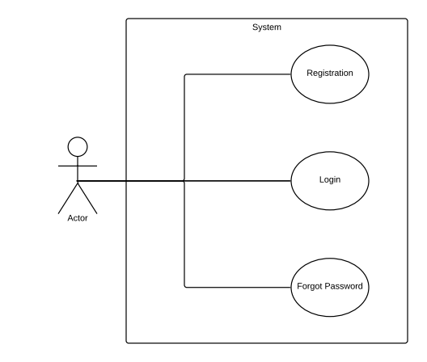

- Section Fetcher Module:

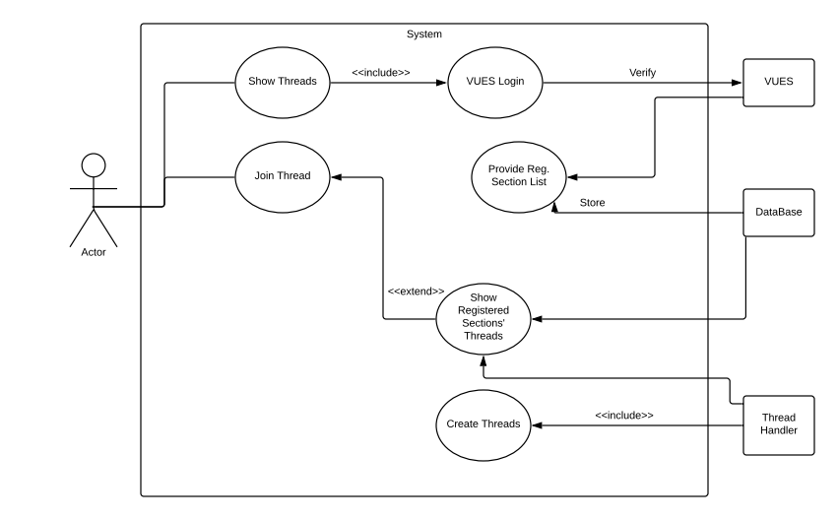

- Thread Module:

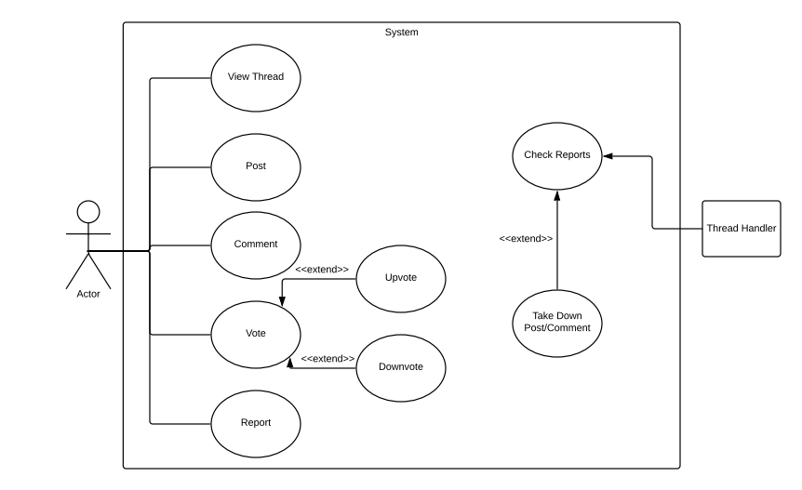

Overall Use Case Diagram of the System:

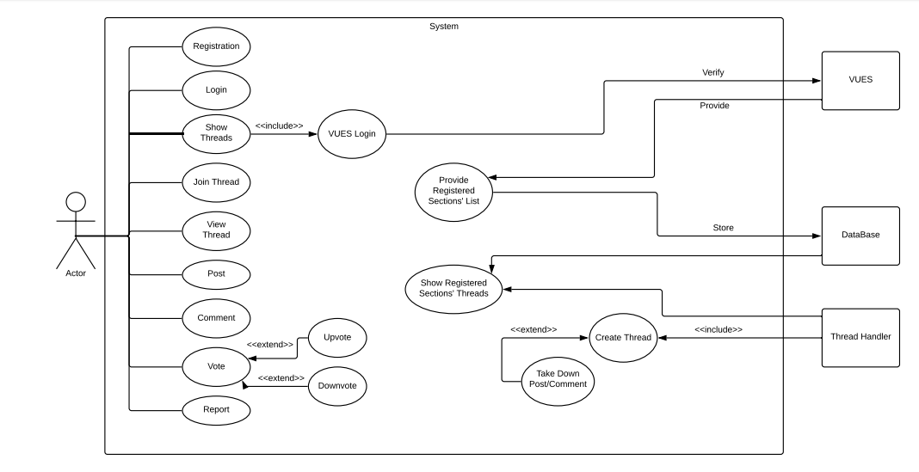

Class Diagram for the System:

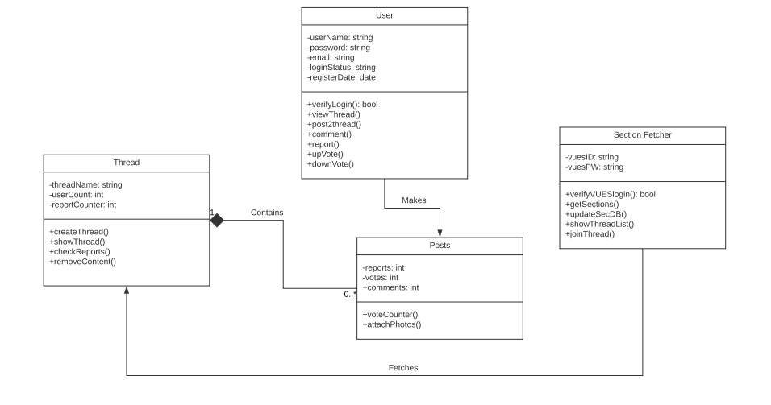

Activity Diagram for Some Critical Part of the System:
- Activity Diagram of Section Fetching and Joining a Thread:

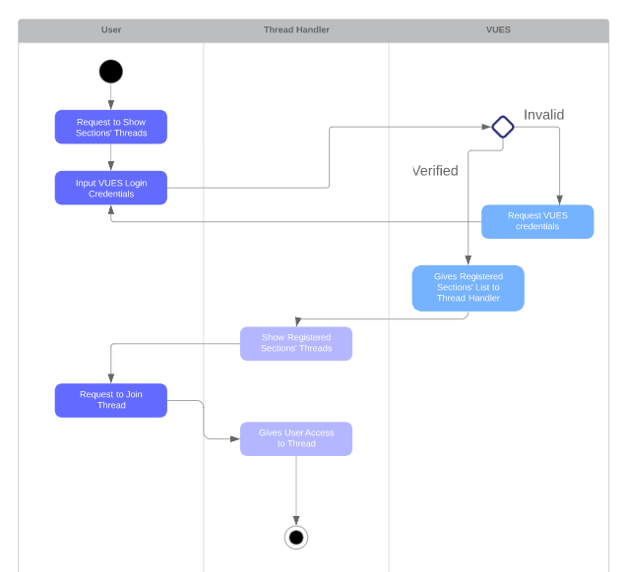

Conclusion:
Applications are made to make our lives easier. The current go-to place for us to look for help regarding our academic issues is Facebook group or group chats, where someone has to create it and then find and add the rest of the members for them to get in touch with each other. As much as this manual process is widely adapted by all of us, this is very time consuming. We all know about the unnecessary and irrelevant chats in the group chats, and not being able to find your course mates easily in the Facebook group either. This threaded discussion newsgroup can eliminate all those problems and automate the process at the same time. Now a student just has to register in the application and just ask the application to show him his section threads, that will access him to section wise separate threads. And in most cases, threads are more efficient because the conversations on threads are mostly to the point, avoiding any unnecessary elements. All in all, just like ‘Make My Schedule’ which helps us with our pre-registration, this can also be a really helpful tool for all of us AIUBians.

